Pre-donation Education Materials to blood donors

Dear Blood Donor,  Thank you for donating blood today. Your valued donation is a vital contribution to our community, and we sincerely hope that you have found it a worthwhile experience. We would like to advise you to read carefully the following points for care before blood donation. If you have any enquiry regarding donation matters, please ask the donation service.  Donation Process:  For your safety and safety of patients receiving your blood:  We will determine if you are eligible to donate:  - Ask questions about your health, travel, medications, and behaviors that could be risky for certain diseases like hepatitis and the HIV infection of AIDS.  - Take your blood pressure, temperature & pulse.  - Perform hemoglobin or complete blood count.  - inspect your arms to determine if your veins are suitable for donation process. | If you are able to donate, a phlebotomist will:  - Cleanse your arms with an antiseptic. If you are allergic to iodine, please tell the person drawing your blood.  - Use a new, sterile, disposable needles to collect your blood. Donation will take about 2 hours.  Donor Eligibility:  - Prescription and Non-Prescription Medicines: You will he asked about specific medicines. If you are taking or have taken certain medicines, you may be asked not to donate blood. If you have any questions about prescription or non-prescribed medicines you are taking or have taken in past, consult a donor service staff.  - Transfusion, Transplants, and Grafts: you have had a blood transfusion, transplant or a graft such as bone or skin the past 12 months, you are ineligible to give blood today.  - Hemophilia or use of clotting factor concentrates: If you have a bleeding disorder as hemophilia and/or have received clotting factor concentrates, you are not eligible to donate. | - Travel to or Birth in Other Countries: Being born in, residing in, or visiting certain countries may make you ineligible to donate today. This is because some infectious diseases are found only in certain countries, and we may not have tests for those diseases. Periodically, additional countries are placed on the deferral list, so please ask blood center staff about trips you may have outside the kingdom.  ACCURACY AND HONESTY ARE KEY!  Your complete honesty in answering the donor questions is very important for the safety of patients who receive your blood. All information you provide is confidential. You will be requested to sign a statement that you have read this material, understand it, and will not give blood if you are at high risk of getting HIV, hepatitis or other infections.  Self-Exclusion and Self-Deferral!  You can withdraw from donation at anytime you feel you are not suitable for donation without giving reason or you call back within 24 hours for donor unsuitability at telephone no. 0126375555 extinction 1229 or / the hospital operator 1904 and give him paper slip containing telephone numbers. This shall be done with privacy and strict confidentiality.
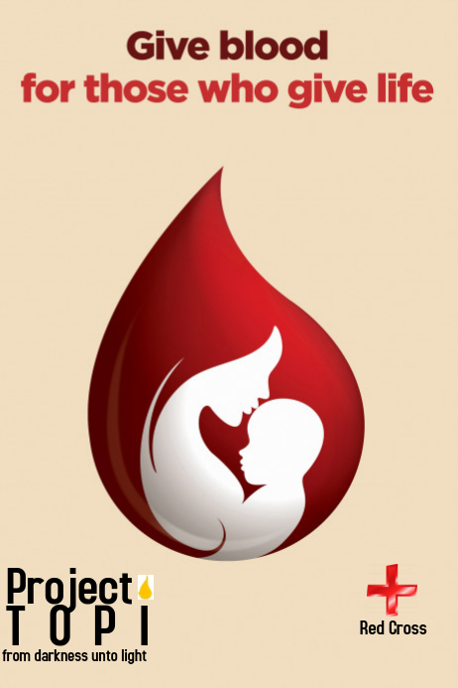  THANK YOU FOR DONATING BLOOD TODAY!  P.O. Box: 31467 Jeddah 21497  Telephone: 0126375555/1229  Fax number: 0126379442  Appointment via: wateenapp.org | What diseases may be transmitted by blood?”  Blood donated can transmit HIV, HBV, HCV, HTLV I & II, Syphilis & Malaria. Blood is tested for each.  Other disease can be transmitted although not tested as cow madness, Dengue & others.  HIV/AIDS risk behaviors  HIV is the virus causes AIDS. It is spread mainly by sexual contact with an infected person OR by sharing needles or syringes used by an infected person for injecting drugs. Do not donate if you:  Have AIDS or ever had a positive HIV test  - Are a male who has had sexual contact with another male, in the past 12 months.  - Have had sexual contact in the past 12 months with anyone described above.  - Have EVER taken money, drugs or other payment for sex  - Have had syphilis or gonorrhea in the past 12 months.  - Have been in juvenile detention, lockup, jail or prison for more than 72 consecutive hours in the past 12 months | Your blood can transmit infections, including HIV/AIDS, even if you feel well and all your tests are normal because even the best tests cannot detect the virus for a period of time after you are infected.  DO NOT donate to get a test! If you think you may be at risk for HIV/AIDS or any other infection, do not donate simply to get a test. Ask us where you can be tested outside the blood center.  The following symptoms can be present before an HIV test turns positive:  Fever, Rash & Sore throat  Enlarged lymph glands  DO NOT donate if you have these symptoms!  What happens after your donation?  To protect patients, your blood is tested for several types of hepatitis, HIV, syphilis, and other infections. If your blood tests positive it will not be given to a patient. You will be notified about any positive test result which may disqualify you from donating in the future. The blood center will not release your test results without your written permission unless required by law (e.g. to the Health Department)

